1. Unwanted pop up display while navigate the dashboard 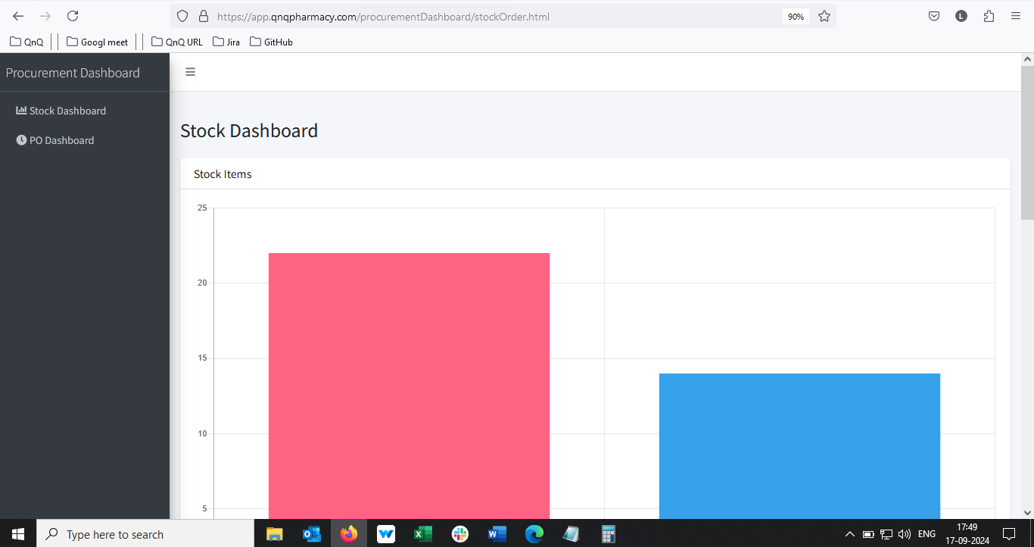 //
2. Minus value display in graph when there is no data available 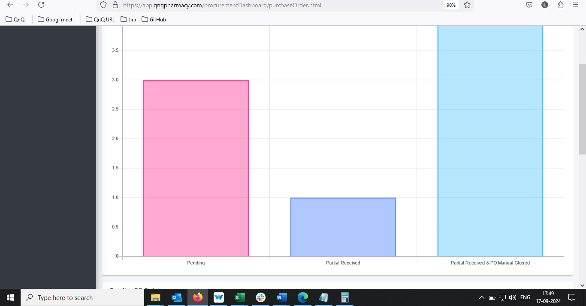
3. Mismatch header value display in graph section 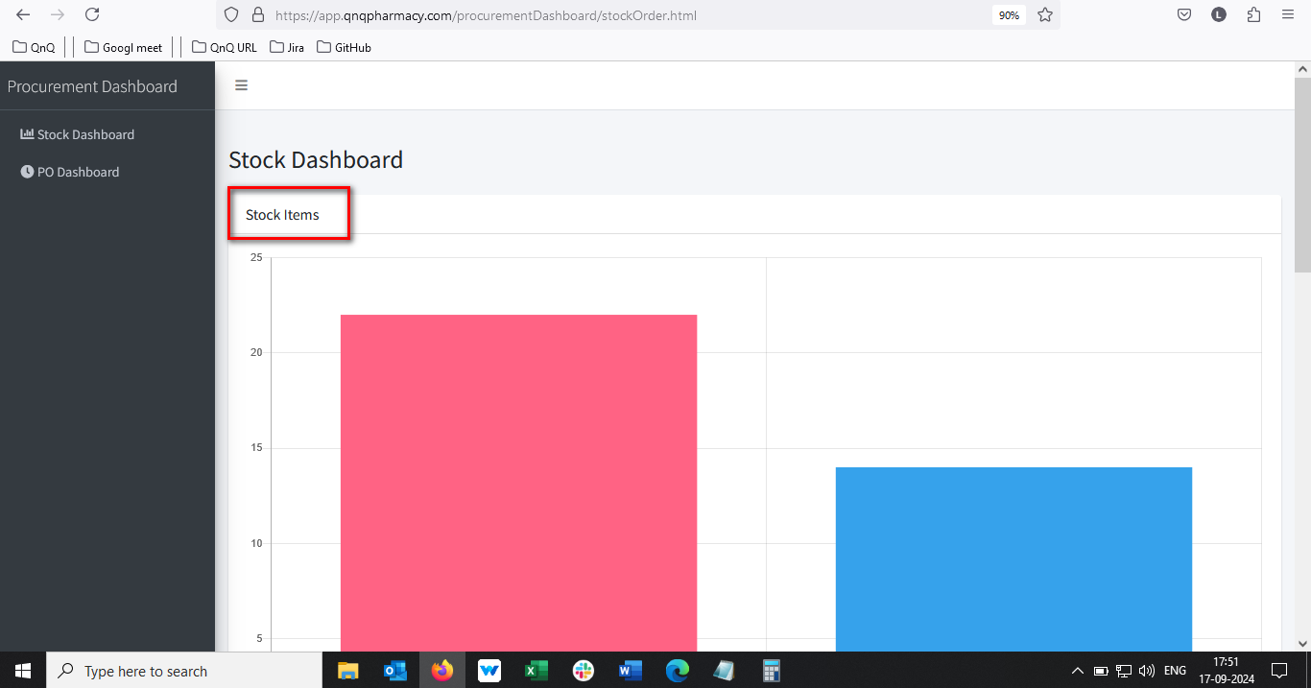 //
4. Decimal value display in graph y axis section- **Reopen** //
5. Unwanted colour highlighted bar display in top of the graph section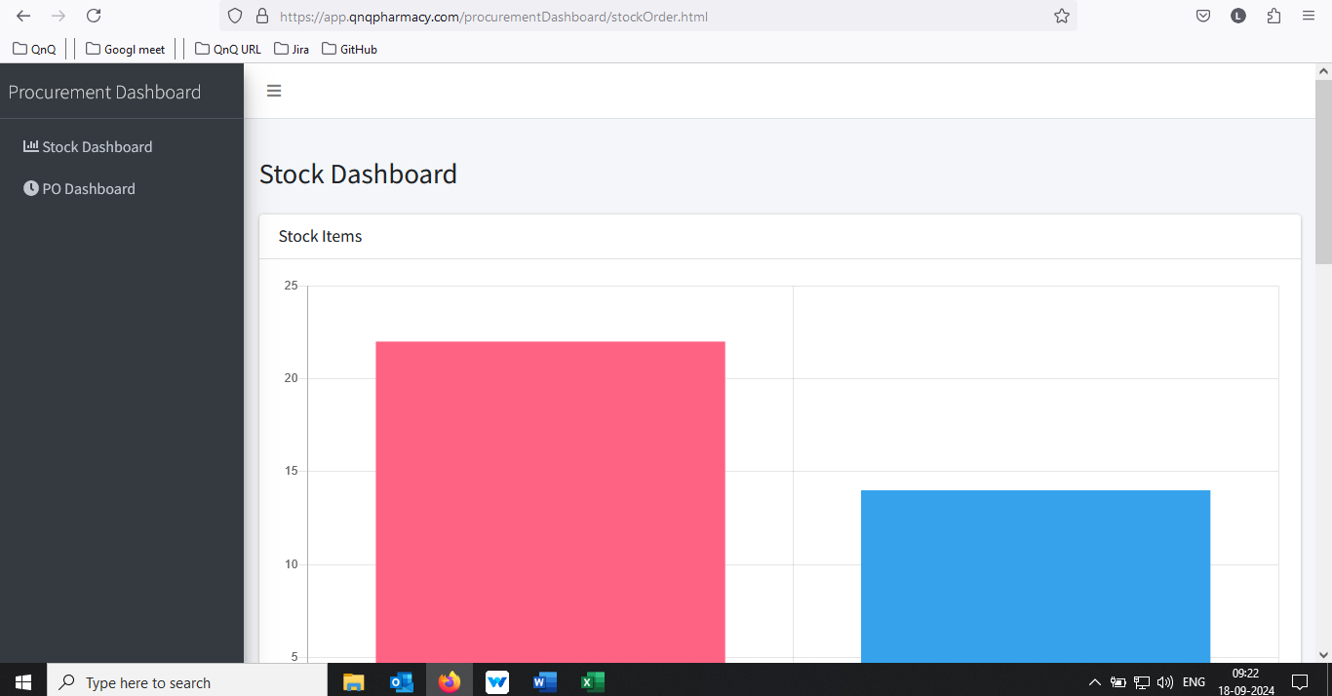//
6. Unwanted content display in graph tooltip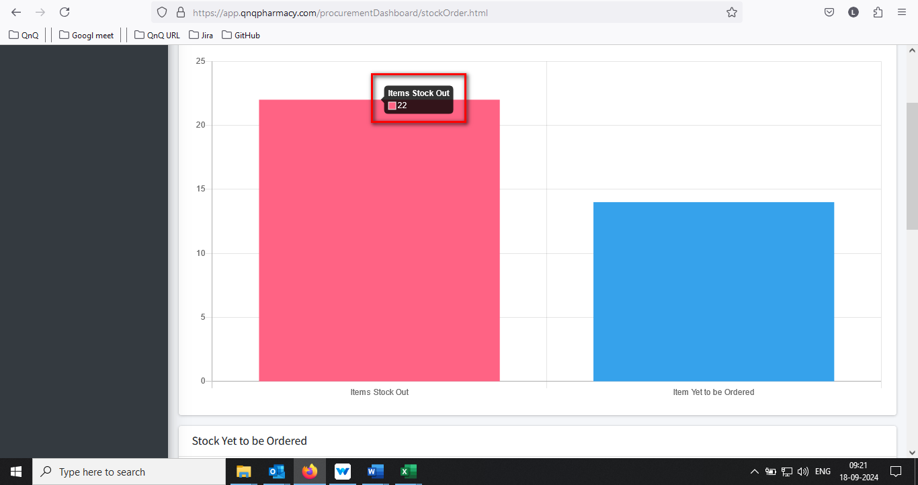 //
7. Mismatch status label name display in list grid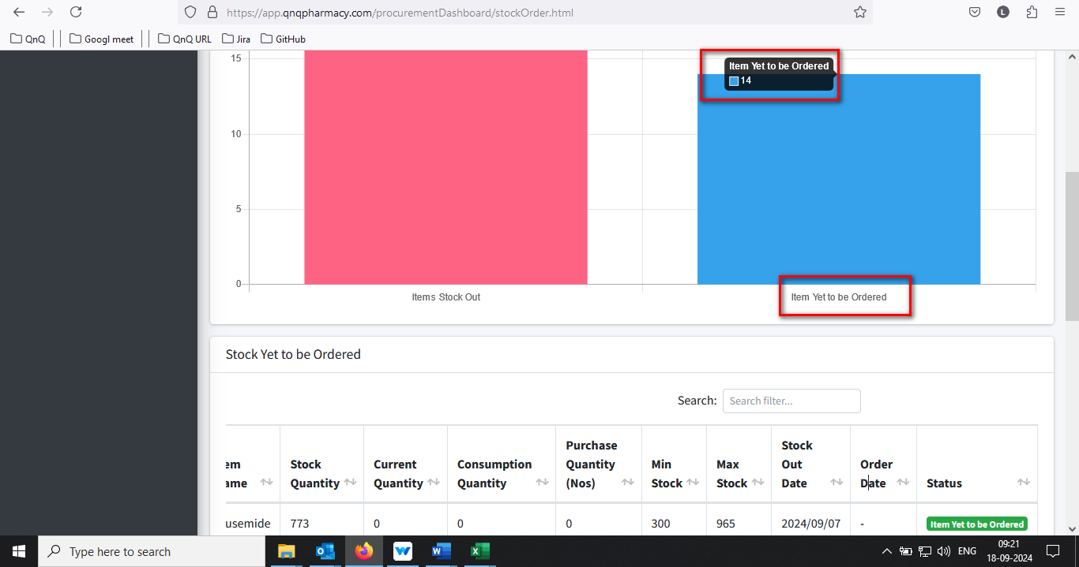//
8. Order date column display the value as “undefined” 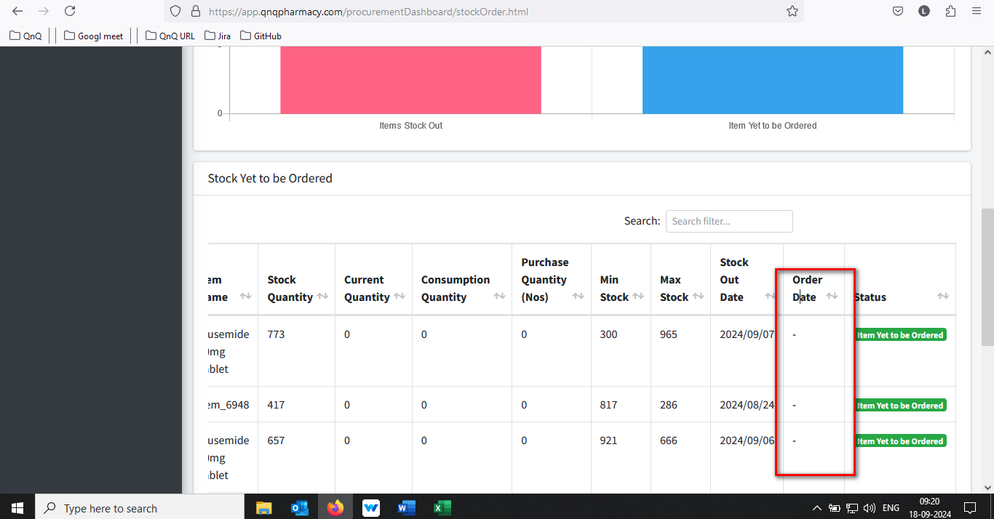//
9. Column name display improper alignment in list grid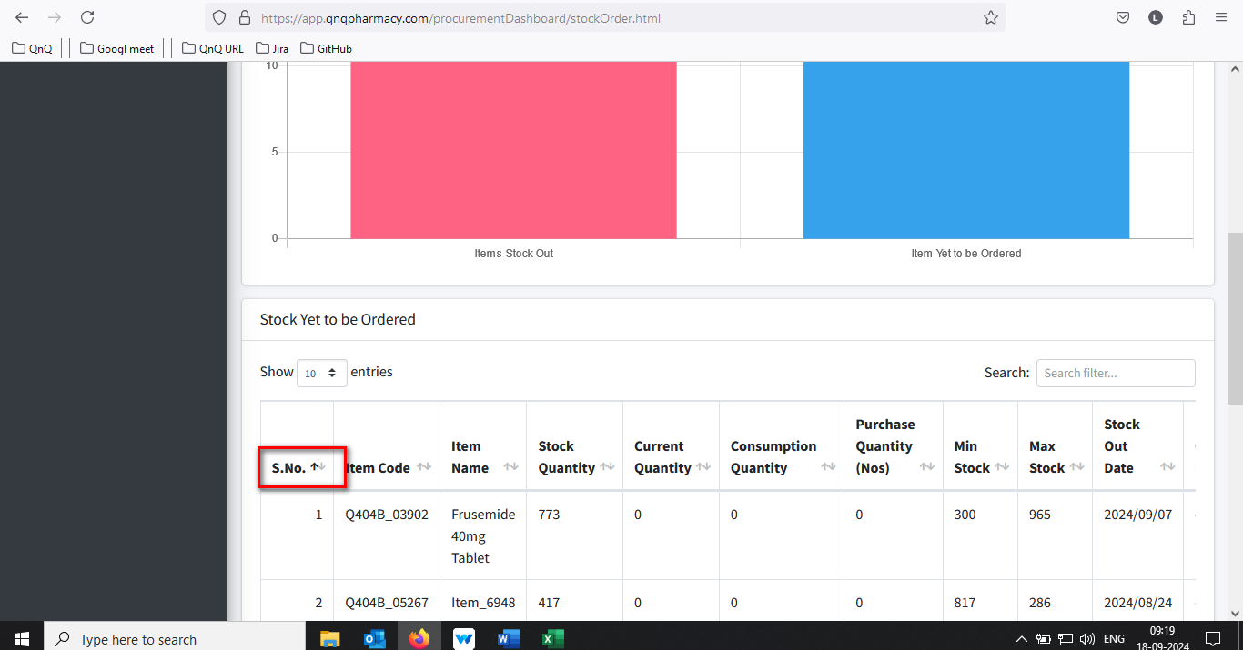//
10. Placeholder or inner text not display in Search filter text box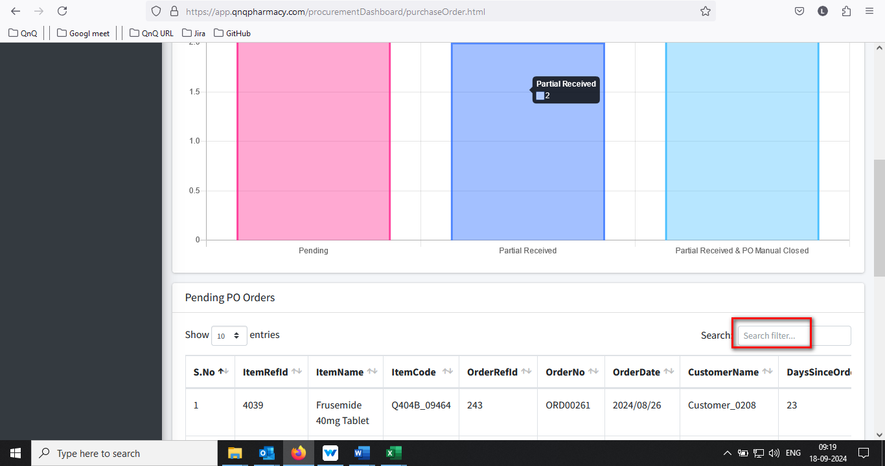//
11. Time value display in Stock out date column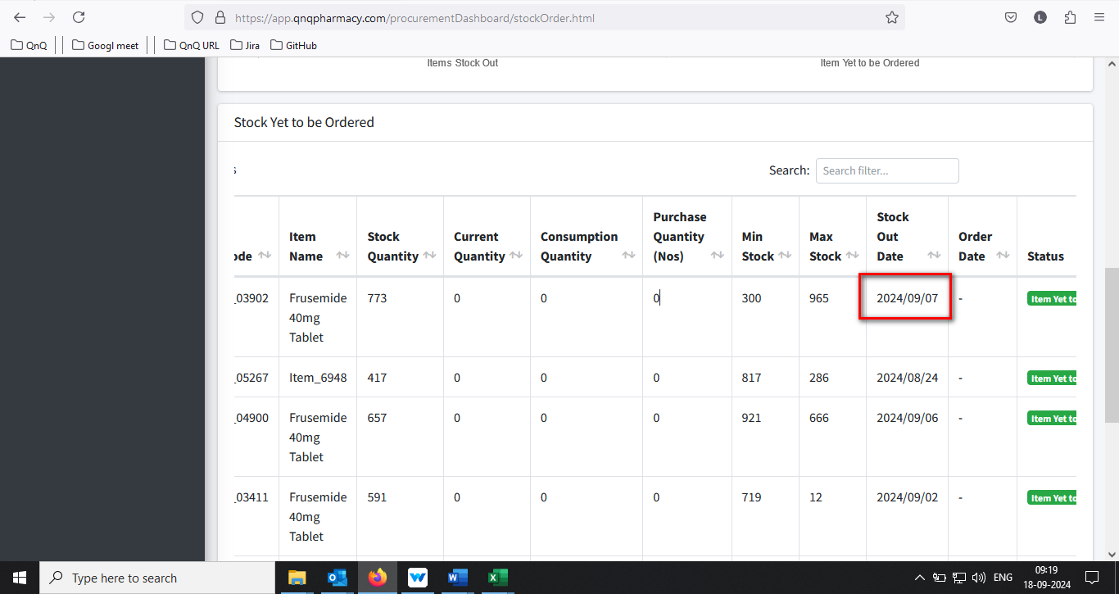//
12. Dot value not getting display for S.No. 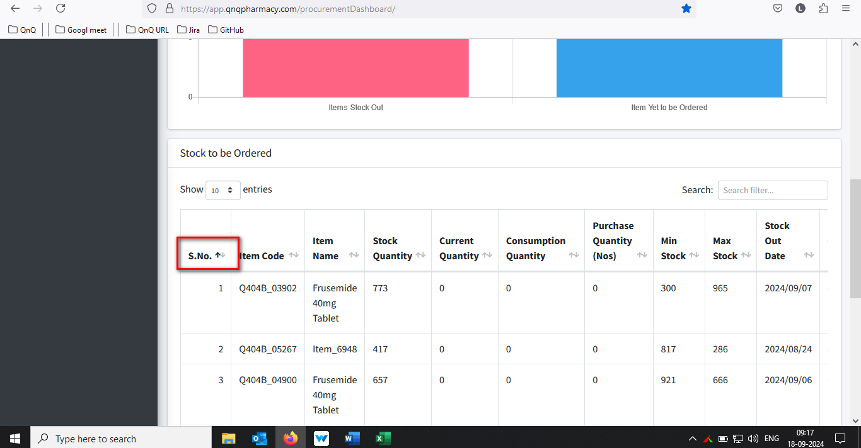//
13. Mismatch menu icon display for Stock Dashboard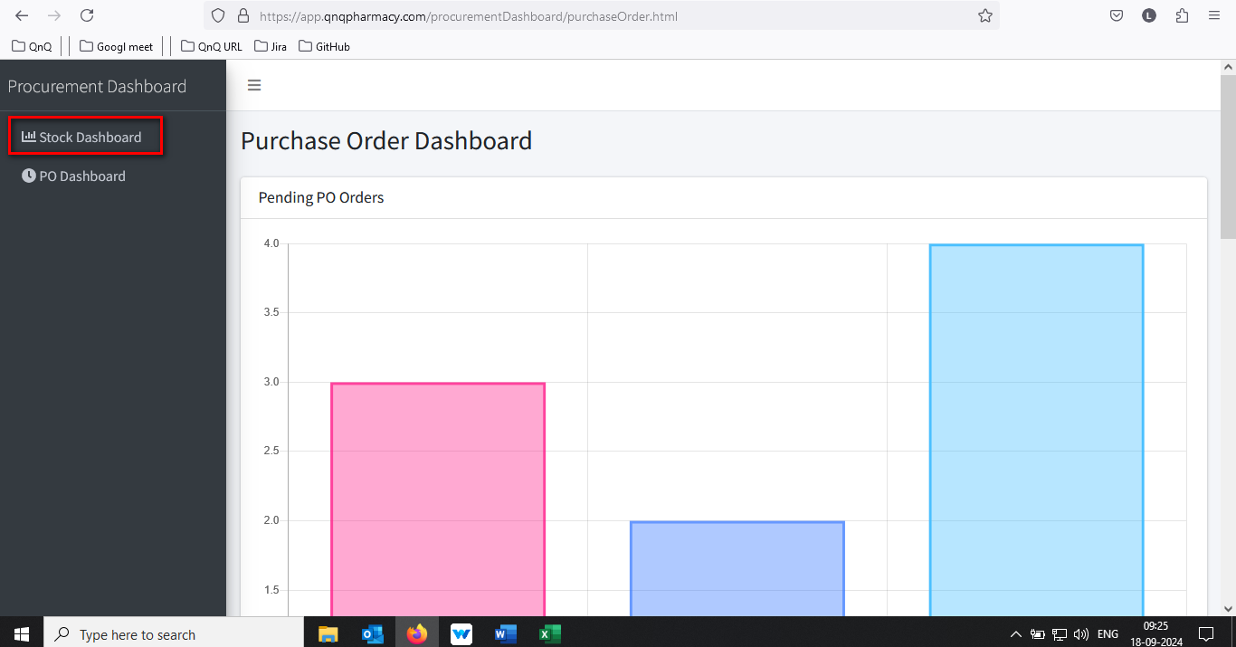//
14. List grid alignment getting collapse while zoom out the web page view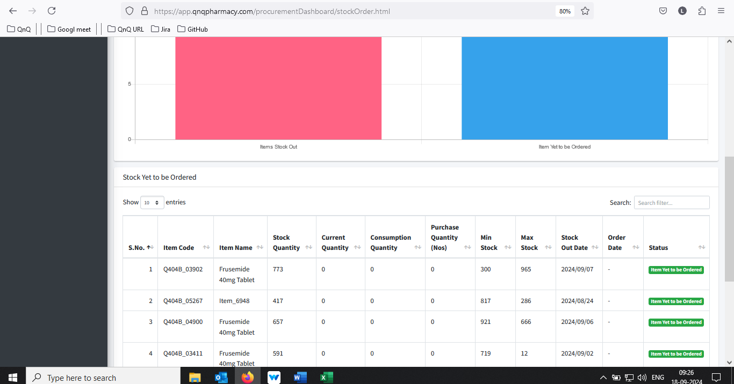//
15. Sort icon display as too small - Deferred//
16. Mismatch date format display in list grid -Close 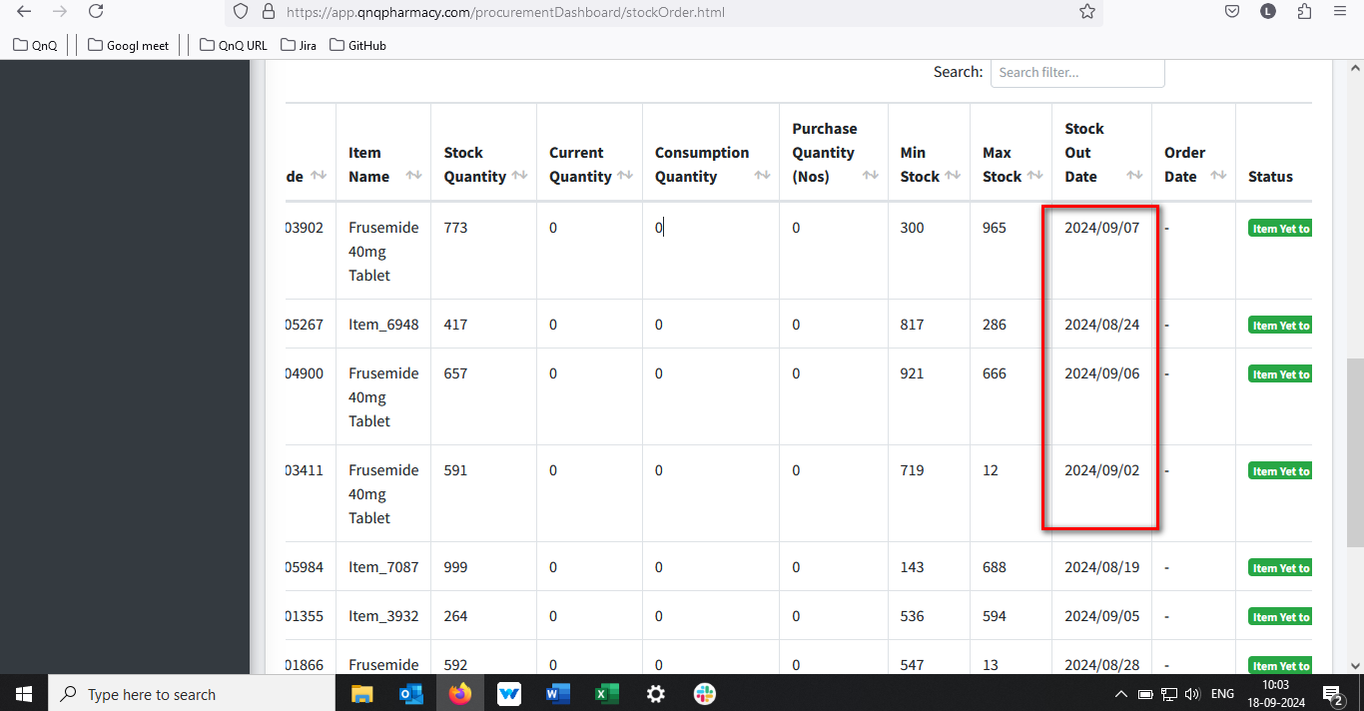 //
17. Mismatch header value display in list grid 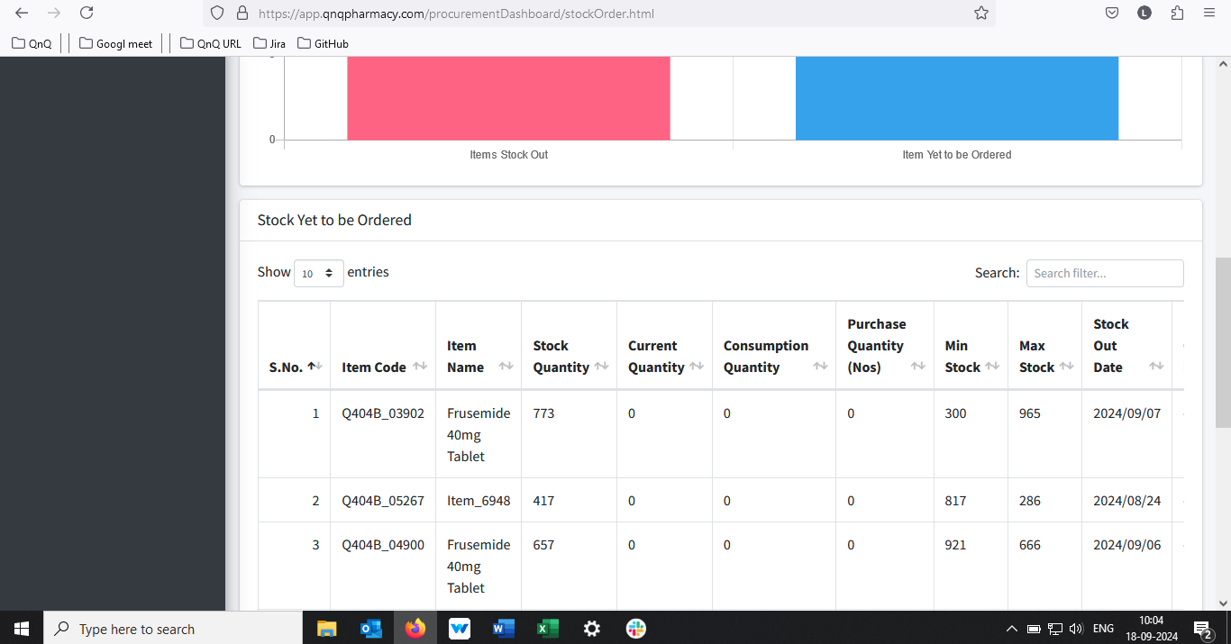 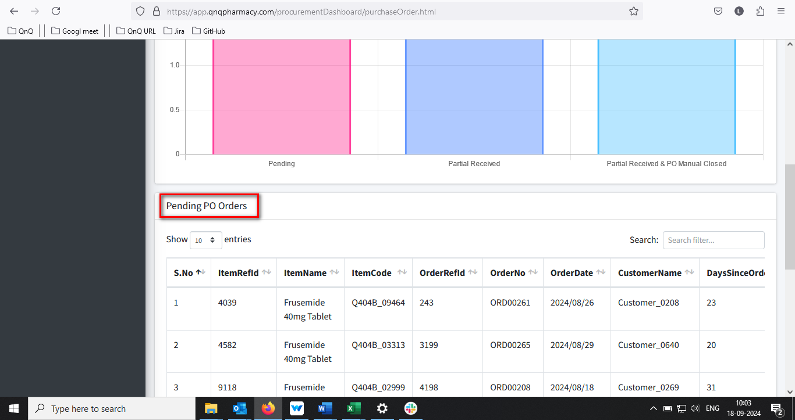 //
18. Unwanted colour highlighted bar display in top of the graph section 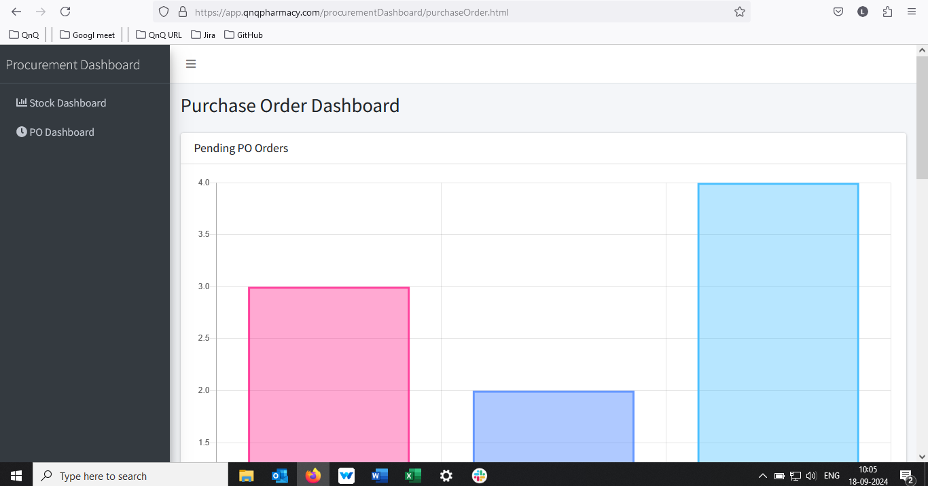 //
19. Unwanted content display in Po Dashboard graph tooltip 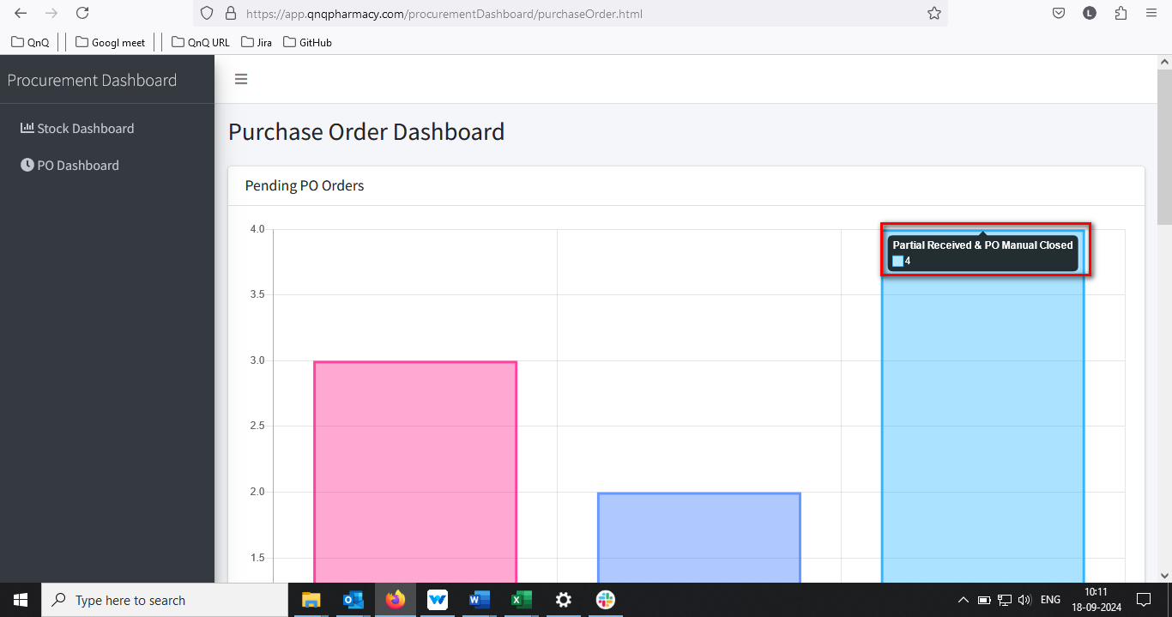 //
20. Column name display improper alignment in Po Dashboard list grid 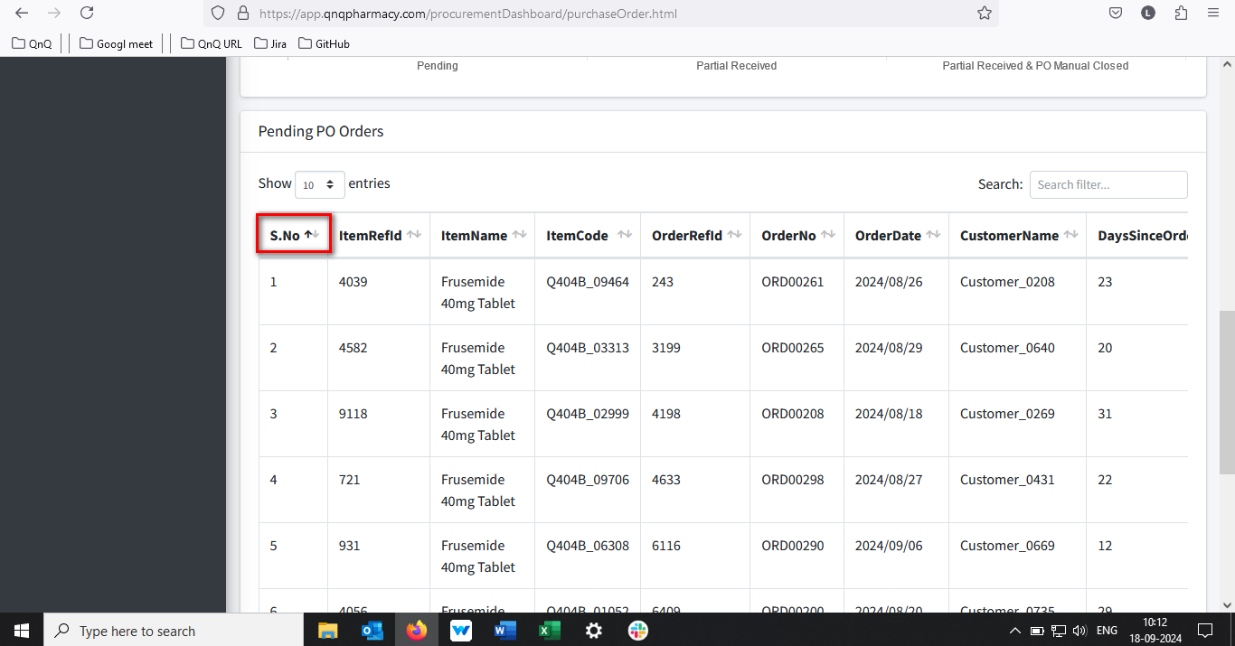 //
21. Dot value not getting display for S.No. --- Reopen//
22. Mismatch menu icon display for Po Dashboard--- Reopen //
23. List grid alignment getting collapse while zoom out the web page view--Close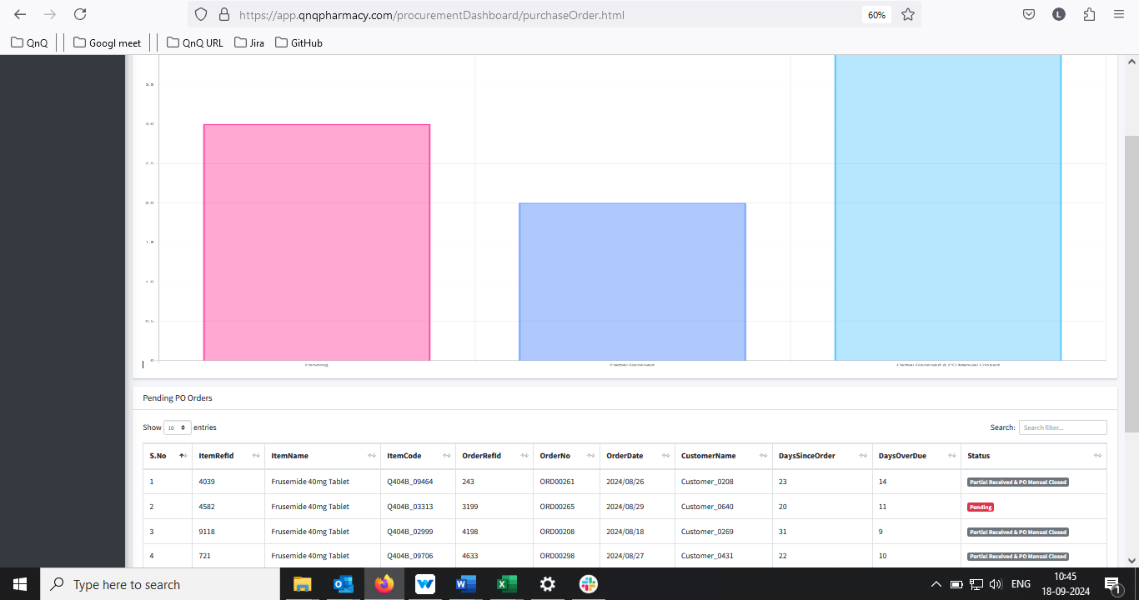 //
24. Mismatch date format display in list grid 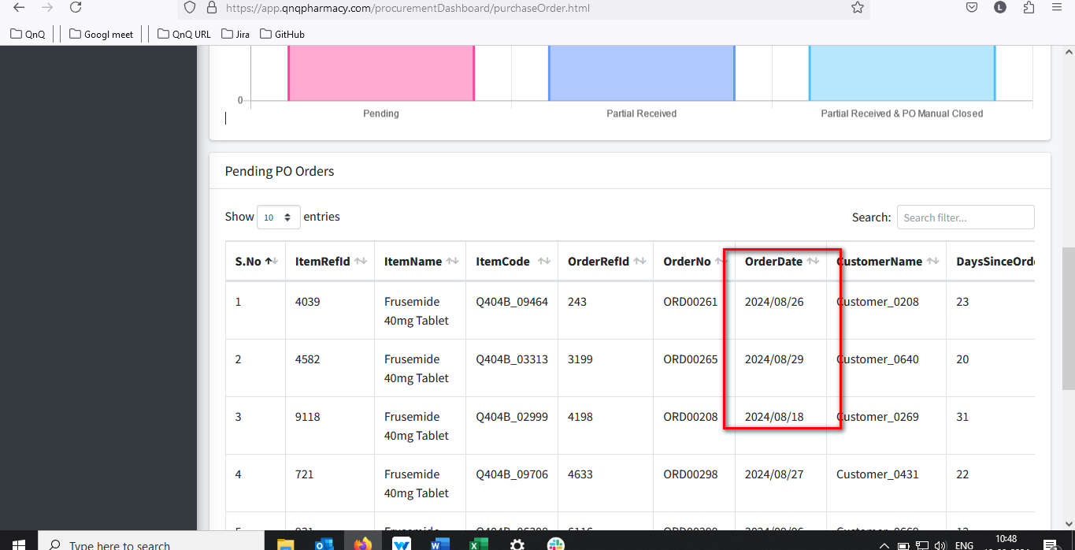 //
25. All Column header name display without space -- Deferred//